Introduction To Medical Imaging
Medical Imaging refers to the use of various techniques and technologies to visualize the internal structures and functions of the human body for clinical analysis and medical intervention. The goal is to diagnose, monitor, and treat diseases or conditions by creating detailed images that can be interpreted by medical professionals. These images help to detect abnormalities, guide treatments, and assess the effectiveness of interventions.
Key modalities of medical imaging include:
- X-ray Imaging: One of the oldest and most widely used forms, primarily for visualizing bones and detecting issues like fractures, infections, and tumors. It uses radiation to capture images of the inside of the body.
- Magnetic Resonance Imaging (MRI): Uses strong magnetic fields and radio waves to generate detailed images of soft tissues, such as the brain, muscles, and internal organs, without using ionizing radiation.
- Computed Tomography (CT): Combines X-ray technology with computer processing to create cross-sectional images (slices) of the body. It is particularly effective for detecting internal injuries, cancers, and vascular conditions.
- Ultrasound: Uses high-frequency sound waves to produce images, typically for monitoring pregnancy, abdominal issues, and heart conditions. It is non-invasive and radiation-free.
🏥 Medical Imaging Trends to Watch in 2025
🌐 1. Rise of Generative AI in Radiology
- Generative AI using foundational models for:
  - Patient summarization
  - Clinical history consolidation
- Surge in AI product development and deployment in radiology
- Multi-modal AI gaining traction:
  - Integrates data from clinical notes, labs, EMR, images
  - Provides more comprehensive and personalized insights
🧠 2. Personalized Imaging
- Shift from one-size-fits-all to tailored radiology for each patient
- Reflects broader personalized medicine trend
🧪 3. Key Technological Innovations Expected in 2025
- Photon-counting CT
- Digital SPECT
- Whole-body MRI
- Helium-free MRI:
  - Lightweight and compact
  - Easier installation
  - Suitable for mobile units and older facilities
🏥 4. Enhanced Access & Portability
- Expansion of portable and point-of-care imaging systems:
  - Lightweight X-ray and cone-beam CT
  - Explosion of POCUS (Point-of-Care Ultrasound) devices
- AI-equipped portable devices:
  - Empower non-specialists with real-time diagnostic support
  - Particularly impactful in rural and underserved regions
🧭 5. Market Expansion & Competition
- New vendors entering imaging markets
- Asian vendors expanding beyond domestic territories
- Growth of strategic partnerships across imaging products/services
- Result: More competition, diverse supply chains, and pricing changes
🧾 6. Regulatory Developments
- Integration of AI in medical records and imaging systems may trigger:
  - Regulatory oversight
  - Reviews to assess potential impact on direct patient care
💵 7. Economic & Political Influence
- Budget constraints due to global political and economic uncertainty may affect:
  - Purchases of high-end imaging modalities
🩺 8. Trends by Specialty
🫀 Cardiology
- Coronary CT Angiography (CCTA) becoming primary diagnostic tool for chest pain
- US Reimbursement for CCTA to double in 2025
- Reflects CCTA's growing clinical utility
🫁 Oncology (Lung Cancer)
- Surge in CT lung cancer screenings leading to:
  - Increased lung biopsies
  - Use of mobile C-arms for image guidance
  - Expansion in ablation procedures
🩻 Breast Imaging
- Participation barriers for women remain
- Companies responding with patient-centric solutions for:
  - Dense breasts
  - High-risk profiles
📊 9. Radiology IT Ecosystem
- IT deals becoming more complex, going beyond multimodality PACS to include:
  - Specialist reporting tools
  - Clinical AI modules
  - Broad service packages
🔗 10. Connected Devices & Remote Monitoring
- Imaging devices increasingly connected for:
  - Real-time data sharing
  - Remote diagnostics
  - Advanced AI-based image analysis
Images
Images are visual representations that convey information, concepts, or artistic expression. They are created by capturing or generating visual data, which can be displayed in various formats. Images are used in diverse fields, including art, science, medicine, and digital media, serving as tools for documentation, analysis, and communication.
Different Types of Images
- Raster Images:
  - Description: Composed of pixels (small squares) arranged in a grid, each pixel holds a color value.
  - File Formats: Common formats include JPEG, PNG, BMP, GIF, and TIFF.
  - Characteristics: Raster images are resolution-dependent, meaning they lose quality if scaled up. They’re ideal for photographs and images with complex color gradients.
- Vector Images:
  - Description: Defined by mathematical formulas rather than pixels, allowing lines and shapes to form the image.
  - File Formats: Common formats include SVG, EPS, and PDF.
  - Characteristics: Vector images are resolution-independent, meaning they can be scaled to any size without loss of quality. They’re suitable for logos, icons, and illustrations with clear lines and shapes.
- 3D Images:
  - Description: Represent three-dimensional objects and can display depth, making them appear lifelike.
  - File Formats: Common formats include STL, OBJ, and FBX.
  - Characteristics: Used in applications like video games, virtual reality, and simulations; 3D images require specialized software to create and manipulate.
- Medical Images:
  - Description: Captured using medical imaging techniques like MRI, CT scans, and X-rays.
  - File Formats: Typically stored in DICOM format, specific to medical imaging.
  - Characteristics: Used in healthcare to visualize internal body structures, aiding diagnosis and treatment.
- Binary Images:
  - Description: Consist of only two colors, usually black and white.
  - Characteristics: Often used in document scanning and pattern recognition, where only two values (0 and 1) represent the image.
- Thermal Images:
  - Description: Capture heat patterns rather than visible light.
  - File Formats: Typically stored in formats compatible with thermal imaging software.
  - Characteristics: Used in fields like surveillance, medical diagnostics, and energy audits to detect temperature variations.
- Hyperspectral Images:
  - Description: Capture a wide range of wavelengths across the electromagnetic spectrum, beyond visible light.
  - Characteristics: Used in applications like agriculture, environmental monitoring, and mineral exploration to identify materials based on their spectral signature.
Each image type has specific use cases based on its structure, format, and characteristics, serving various industries and applications.
Types of Images in Medical Imaging: Grayscale, Color, and Digital Images
- Grayscale Images:
  - Definition: Grayscale images consist of a single channel that represents shades of Gray. Each pixel has an intensity ranging from black (0) to white (maximum value, usually 255 in an 8-bit image).
  - Range: 0 (black) to 255 (white) in 8-bit format, or from 0 to 65,535 in 16-bit grayscale images.
  - Usage in Medical Imaging: Commonly used for X-rays, MRI, CT scans, and ultrasound images, where color isn’t necessary. Grayscale helps highlight details in tissue density, bone structure, and internal organs, which are crucial in medical diagnosis.
- Color Images:
  - Definition: Color images use multiple channels (usually three: red, green, and blue) to produce a full spectrum of colors. Each pixel has three values representing the intensity of red, green, and blue, creating a combined color.
  - Range: 0 to 255 per channel in 8-bit RGB, resulting in over 16 million possible colors.
  - Usage in Medical Imaging: Less common than grayscale but used in dermatology, endoscopy, and some pathology applications, where color differences are essential for identifying conditions such as lesions or tissue inflammation.
- Digital Images:
  - Definition: Digital images are any images stored in a pixel-based format on digital devices. They can be grayscale, color, or binary (black and white).
  - Range: Depends on the image type; digital images can be 1-bit (binary), 8-bit (grayscale), 24-bit (RGB color), etc.
  - Usage in Medical Imaging: Encompasses both grayscale and color images, digitizing data from scans for easy storage, sharing, and analysis. Digital imaging allows AI algorithms to assist with automated analysis, pattern detection, and image enhancement in medical diagnostics.
Grayscale images are most widely used in medical imaging due to their focus on structural details, while color images are used selectively in fields where color differentiation is diagnostically significant. Digital images enable the digitization and processing of both types, supporting advancements in automated diagnostics.
DICOM (Digital Imaging and Communications in Medicine) is a standard format used to store, transmit, and view medical imaging data. It is widely used in radiology and other fields of medicine for images generated by modalities like X-ray, MRI, CT, ultrasound, and PET scans. Here are some key aspects of the DICOM format:
- Data and Metadata: DICOM files contain both the actual image data (e.g., X-ray, MRI scans) and metadata, which includes patient information (e.g., ID, age, gender), imaging parameters (e.g., exposure time, resolution), and the specific conditions under which the image was acquired.
- File Extension: DICOM files typically have the extension. dcm, though not all DICOM files follow this convention.
- Storage and Transmission: DICOM allows for consistent storage, retrieval, and sharing of medical imaging data across different systems and facilities. It is compatible with Picture Archiving and Communication Systems (PACS), which hospitals use for storing and managing medical images.
- Unique Identifiers: Each DICOM file includes unique identifiers, such as Study, Series, and Image IDs, which help track and organize multiple images or scans for the same patient over time.
- Standardization: The DICOM standard ensures interoperability, enabling images and information to be accessible on different types of imaging equipment and viewing software. This helps in seamless sharing of patient information across different healthcare settings.
- Image Compression: DICOM files can be large, so they often include options for compression, either lossless (preserving all details) or lossy (for smaller file sizes at the cost of some image data loss).
- Viewers and Software: Specialized DICOM viewers are used to display and analyze these files. Examples include OsiriX, RadiAnt, and commercial PACS viewers used in clinical environments.
- Python Libraries for Handling DICOM:
  - Pydicom: A Python library to read, modify, and write DICOM files. It’s widely used for basic DICOM file manipulation.
  - SimpleITK and ITK: Libraries that allow for DICOM image processing, especially in machine learning and image analysis tasks.
  - Dicompyler: A library focused on handling radiation therapy DICOM data.
Why Grayscale Images Are Commonly Used in Medical Imaging:
- Simple and Clear:
Medical images like X-rays, MRIs, and CT scans don’t need color—they show how strong the signal is at each point. Grayscale (black to white) is perfect for this, making the data easier to handle and understand.
- Shows Body Structures Clearly:
Different body parts (bones, tissues, fluids) reflect different shades of gray. This helps doctors see problems like fractures or tumors.
  - X-rays/CT scans: Bones look white, soft tissues look gray, and air looks black.
  - MRIs: Different tissues appear in different grays, helping spot issues in the brain or muscles.
- Focus on What Matters:
Diagnoses are based on shape, contrast, and edges—not color. Grayscale helps highlight these features better than color images.
- Takes Up Less Space and Power:
Grayscale images use only one data layer, while color images use three (red, green, blue). That means grayscale uses less memory and is faster to process.
- Less Noise:
Fewer data layers mean less interference or unwanted "noise" in the image—this improves clarity, which is crucial in medical analysis.
- Built for Grayscale:
Many medical tools and methods were originally made for grayscale. Doctors are trained to read them this way, and software is often designed around grayscale input.
- Helps Focus on Diagnosis:
The goal is to spot problems, not to add color. Grayscale keeps the focus on structures and patterns, which are key to finding diseases.
What Happens When Grayscale Images Are Converted to Color (RGB):
- RGB images have 3 channels; grayscale has only 1.
- Converting a grayscale image to RGB just copies the same gray values into all three color channels.
- This increases file size without adding any useful information.
- However, some pre-trained models (like VGG16 or ResNet) require RGB input, so conversion is sometimes needed to make images compatible with these models.
Why CNN Filters Are Usually Odd-Sized (like 3x3, 5x5):
- Focus on the Center:
Odd-sized filters have a center pixel, which makes it easier to detect features like edges right in the middle of the image patch.
- Padding Is Simpler:
With odd sizes, you can pad the image evenly (e.g., 1 pixel all around for a 3x3 filter), keeping output image size the same.
- Better for Feature Detection:
Small odd-sized filters (like 3x3) are great for spotting patterns like edges and textures. Multiple layers of these filters help detect complex features.
- Balanced View:
Odd sizes look at an equal number of pixels around the center, ensuring the filter isn’t biased toward one side.
- Cleaner Math:
Calculations are easier and more consistent with odd sizes, especially near the image borders.
What It Means to Have 64 Filters in a CNN Layer:
- Each Filter Learns Something Different:
You have 64 different filters (e.g., 3x3). Each one tries to learn something unique—like detecting edges, patterns, or shapes in the image.
- Filters Start Random:
At first, filters are just random numbers. As the model trains, it adjusts these filters to better recognize useful features through a process called backpropagation.
- The Data Teaches the Filters:
You don’t tell the filters what to learn. They learn automatically from the training data, based on what helps the model make better predictions.
- Each Filter Creates a Feature Map:
After processing, each filter produces a separate “view” (feature map) of the input. These are stacked and passed to the next layer to learn even more complex features.
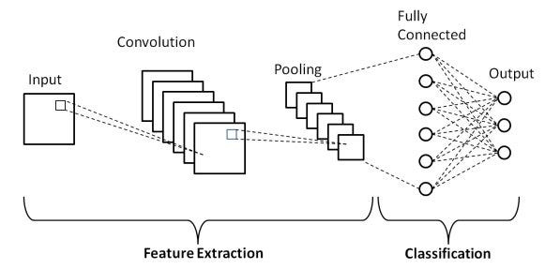


Classification
Definition: Classification is a supervised machine learning task where a model predicts a discrete label or category for a given input based on labeled training data.
Types:
- Binary Classification: Predicts one of two classes (e.g., spam vs. not spam, true vs. false).
- Multi-Class Classification: Predicts one of multiple classes (e.g., classifying images as cat, dog, or bird).
- Multi-Label Classification: Assigns multiple labels to a single input (e.g., tagging a movie with genres like comedy and drama).
- Imbalanced Classification: Deals with datasets where some classes are underrepresented (e.g., fraud detection).
Examples:
- Email spam detection (binary).
- Handwritten digit recognition (multi-class).
- Sentiment analysis (positive, negative, neutral).
Segmentation
Definition: Segmentation typically refers to dividing data into meaningful groups or regions. In machine learning, it’s often associated with image segmentation (dividing an image into regions) or data segmentation (clustering or grouping data points).
Types:
- Image Segmentation:
  - Semantic Segmentation: Assigns a class label to each pixel in an image (e.g., labeling pixels as "car" or "road").
  - Instance Segmentation: Identifies and separates individual objects of the same class (e.g., distinguishing between different cars in an image).
  - Panoptic Segmentation: Combines semantic and instance segmentation, labeling all pixels and identifying instances.
- Data Segmentation (Clustering):
  - K-Means Clustering: Groups data into K clusters based on feature similarity.
  - Hierarchical Clustering: Builds a tree of clusters based on data proximity.
  - DBSCAN: Groups data points based on density, identifying outliers.
Examples:
- Identifying objects in autonomous driving (image segmentation).
- Customer segmentation for marketing (data segmentation).
Differences
Aspect | Classification | Segmentation
Task Type | Supervised (requires labeled data). | Can be supervised (image segmentation) or unsupervised (data clustering).
Output | Discrete labels or categories. | Groups, clusters, or pixel-level regions.
Input Data | Structured data (e.g., features in a table). | Images (for image segmentation) or unstructured data (for clustering).
Goal | Assign a single label to an input. | Divide data into meaningful parts or groups.
Examples | Predicting disease (yes/no). | Dividing an image into objects or grouping customers by behavior.
Algorithms | Logistic Regression, SVM, Random Forest. | U-Net (image), K-Means, DBSCAN (data).

Key Notes
- Classification is about predicting a category for an entire input, while segmentation focuses on dividing data into parts, either spatially (images) or by similarity (clustering).
- Classification requires labeled data, whereas segmentation can be unsupervised (e.g., clustering) or supervised (e.g., semantic segmentation).
- In image processing, classification might label an entire image (e.g., "dog"), while segmentation labels each pixel or region (e.g., outlining the dog).
The retinal fundus refers to the back of the eye, including the retina, optic disc, macula, blood vessels, and other structures visible through an ophthalmoscope. It’s a critical area for assessing eye health and diagnosing conditions affecting vision or systemic diseases like diabetes or hypertension.
What is the Retinal Fundus?
The fundus is the inner lining of the eye, primarily the retina, which contains light-sensitive cells (photoreceptors) that convert light into neural signals for vision. The macula, located at the centre of the retina, is responsible for sharp central vision, while the optic disc is where the optic nerve exits the eye, carrying visual information to the brain.
How Retinal Fundus Issues Occur
Issues in the retinal fundus arise due to various causes, including:
- Vascular Issues: Blocked or leaking blood vessels (e.g., in diabetic retinopathy or retinal vein occlusion).
- Degenerative Changes: Age-related damage, like in macular degeneration.
- Inflammation or Infection: Conditions like uveitis or toxoplasmosis.
- Trauma: Physical injury to the eye.
- Genetic or Congenital Factors: Inherited retinal dystrophies (e.g., retinitis pigmentosa).
- Systemic Diseases: Diabetes, hypertension, or autoimmune disorders affecting retinal blood vessels.
- Toxins or Medications: Certain drugs or toxins can damage retinal tissue.
Types of Retinal Fundus Disorders
Common conditions affecting the retinal fundus include:
- Diabetic Retinopathy:
  - Cause: High blood sugar damages retinal blood vessels.
  - Types: Non-proliferative (mild, with microaneurysms) and proliferative (severe, with new, fragile blood vessels).
  - Symptoms: Blurred vision, floaters, vision loss.
- Age-Related Macular Degeneration (AMD):
  - Types: Dry (gradual retinal thinning) and wet (abnormal blood vessel growth under the macula).
  - Symptoms: Central vision loss, distorted vision.
- Retinal Detachment:
  - Cause: Retina separates from underlying tissue, often due to tears or trauma.
  - Symptoms: Flashes, floaters, curtain-like vision loss.
- Retinitis Pigmentosa:
  - Cause: Genetic mutations causing photoreceptor degeneration.
  - Symptoms: Night blindness, tunnel vision.
- Retinal Vein Occlusion:
  - Cause: Blocked retinal veins causing swelling (edema).
  - Symptoms: Sudden vision loss or blurriness.
- Macular Edema:
  - Cause: Fluid buildup in the macula, often linked to diabetes or vein occlusion.
  - Symptoms: Blurred or wavy central vision.
Diagnosis
Fundus examination is done using:
- Ophthalmoscopy: Direct or indirect visualization of the fundus.
- Fundus Photography: High-resolution images of the retina.
- Optical Coherence Tomography (OCT): Detailed cross-sectional imaging.
- Fluorescein Angiography: Dye-based imaging to assess blood vessel health.
Treatment
Treatment depends on the specific condition:
- Diabetic Retinopathy:
  - Lifestyle: Blood sugar control.
  - Medications: Anti-VEGF injections (e.g., ranibizumab) to reduce vessel leakage.
  - Laser Therapy: To seal leaking vessels or prevent abnormal vessel growth.
  - Surgery: Vitrectomy for severe cases with bleeding or scar tissue.
- Age-Related Macular Degeneration:
  - Dry AMD: Nutritional supplements (AREDS formula with zinc, vitamins C/E, lutein).
  - Wet AMD: Anti-VEGF injections, photodynamic therapy.
- Retinal Detachment:
  - Surgery: Scleral buckle, vitrectomy, or pneumatic retinopexy to reattach the retina.
- Retinitis Pigmentosa:
  - Supportive: Vitamin A supplementation (under medical guidance), low-vision aids.
  - Gene Therapy: Emerging for specific genetic mutations (e.g., Luxturna for RPE65 mutations).
- Retinal Vein Occlusion/Macular Edema:
  - Medications: Anti-VEGF or corticosteroid injections.
  - Laser Therapy: To reduce swelling.
- General Measures:
  - Manage underlying conditions (e.g., diabetes, hypertension).
  - Regular eye exams for early detection.
  - Protective eyewear to prevent trauma.
Prevention
- Control blood sugar, blood pressure, and cholesterol.
- Avoid smoking and limit alcohol.
- Wear UV-protective sunglasses.
- Regular eye checkups, especially for those with risk factors (e.g., diabetes, family history of retinal disease).
For specific cases, consult an ophthalmologist, as treatment varies based on severity and individual factors.

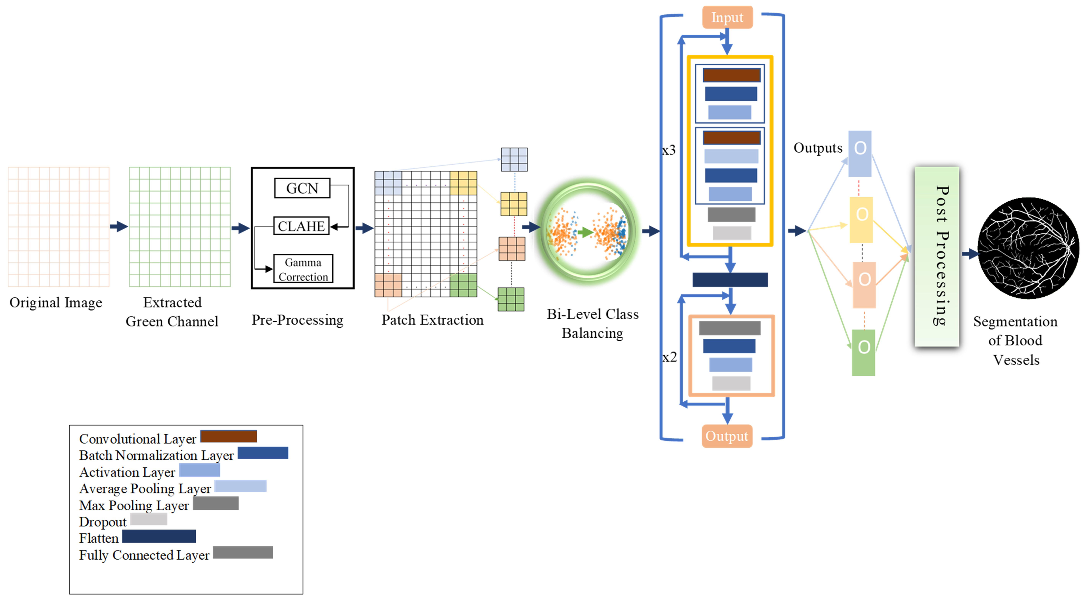
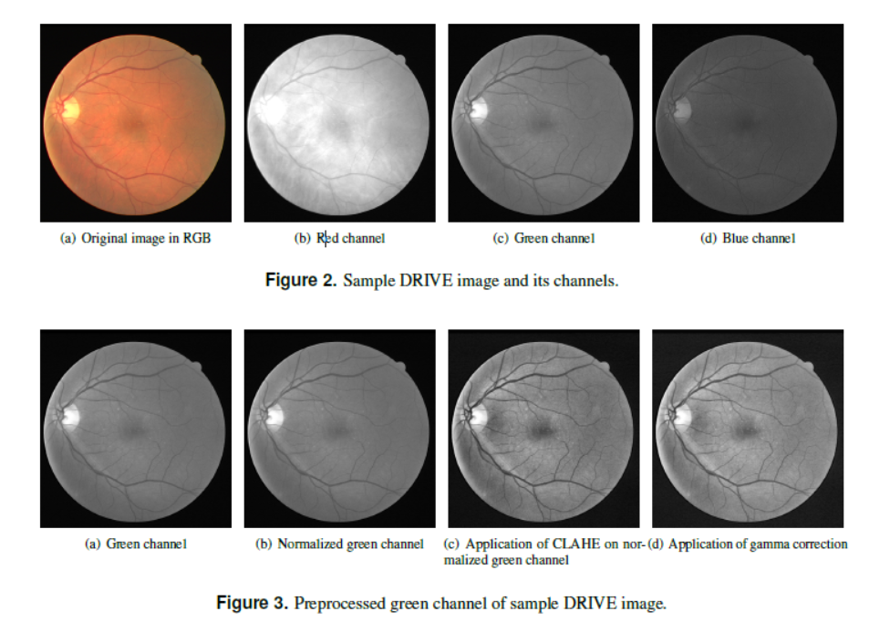
GCN43 (Global Contrast Normalization)
What it does: Global Contrast Normalization (GCN43) evens out brightness across the entire image to reduce variations caused by uneven lighting or shadows in retinal fundus images. This makes the image look more consistent, so blood vessels stand out better against the background.
How it works:
- It calculates the average brightness (mean) and the spread of brightness values (standard deviation) across all pixels in the green channel of the image.
- Each pixel’s brightness is adjusted by subtracting the mean and dividing by the standard deviation. This process "normalizes" the image, making bright and dark areas more balanced.
- Think of it like adjusting the brightness setting on a TV so that no part of the image is too dark or too bright, making details like blood vessels easier to see.
Why it’s useful: Uneven lighting in retinal images (e.g., bright spots or dark corners) can hide vessels. GCN43 ensures the image has uniform brightness, making it easier for the CNN to detect vessels consistently.
CLAHE (Contrast-Limited Adaptive Histogram Equalization)
What it does: CLAHE enhances local contrast in the image, making blood vessels stand out more clearly against the background. Unlike global methods that adjust the whole image, CLAHE focuses on small regions to bring out details.
How it works:
- The image is divided into small tiles (like a grid of mini-images).
- For each tile, CLAHE analyzes the distribution of pixel brightness (called a histogram) and redistributes the intensities to spread them out more evenly. This boosts contrast in that small area, making vessels more visible.
- To avoid over-amplifying noise (e.g., graininess in dark areas), CLAHE "clips" extreme brightness values, keeping the image natural-looking.
- Think of it like zooming in on each part of a photo and adjusting the contrast to make details pop, without making the image look unnatural.
Math: CLAHE doesn’t have a single formula but involves:
- Computing a histogram of pixel intensities for each tile.
- Clipping the histogram to limit extreme values (controlled by a clip limit parameter).
- Redistributing the clipped intensities to enhance contrast, then interpolating between tiles to avoid visible boundaries.
Why it’s useful: Retinal images often have areas where vessels blend into the background due to low contrast. CLAHE makes these vessels more distinct in each small region, helping the CNN identify them accurately.
Gamma Correction
What it does: Gamma Correction balances light and dark areas by adjusting the brightness of pixels in a non-linear way. It makes sure the image isn’t too dark or too bright, improving visibility of blood vessels.
How it works:
- It applies a mathematical transformation to each pixel’s intensity, raising it to a power called the gamma value (γ).
- If γ<1, the image becomes brighter, especially in dark areas, revealing hidden details.
- If γ>1, the image becomes darker, reducing overly bright areas.
- Think of it like tweaking the brightness curve on a photo-editing app to make both shadows and highlights look balanced.
Why it’s useful: Retinal images can have overly dark or bright areas that obscure vessels. Gamma Correction adjusts these extremes, ensuring vessels are visible across the image.
Why These Steps Matter Together
- GCN43 creates a uniform brightness baseline, removing global lighting issues.
- CLAHE enhances local details, making vessels stand out in each part of the image.
- Gamma Correction fine-tunes brightness to balance light and dark areas, ensuring no vessels are hidden. Together, these steps prepare the retinal fundus image for the CNN by making blood vessels clear and consistent, improving segmentation accuracy.

Simplified Explanation of the Model Architecture
The BLCB-CNN methodology uses a Convolutional Neural Network (CNN), a type of artificial intelligence model, to analyze retinal fundus images and identify blood vessels. Think of a CNN as a system that learns to recognize patterns (like blood vessels) in images by breaking them down into smaller pieces and analyzing their features, such as edges, shapes, or textures. The model in this methodology is carefully designed to classify small image patches (64x64 pixels) as either containing a blood vessel or not. The architecture is like a pipeline that processes the image step-by-step to produce a map showing where the blood vessels are.
Here’s how it works in simple terms:
- Input: The CNN takes small patches from the pre-processed green channel of a retinal fundus image (as explained earlier).
- Feature Extraction: The model has several layers that detect features like lines, curves, or vessel patterns. Early layers find simple features (e.g., edges), while deeper layers find complex ones (e.g., vessel shapes).
- Classification: After extracting features, the model decides if each patch contains a vessel or not.
- Output: The results for all patches are combined to create a map of blood vessels in the original image, with some final cleanup to remove errors.
The architecture was fine-tuned using a method called grid search, which tests different settings (e.g., number of layers, learning rates) to find the best combination for accuracy.
Detailed Explanation of the Model Architecture
The CNN architecture in the BLCB-CNN methodology is custom-designed for segmenting blood vessels in retinal fundus images. It processes patches (64x64 pixels) and classifies them as vessel or non-vessel based on their central pixel. Below is a step-by-step breakdown of the architecture:
1. Overview of the Architecture
The CNN consists of:
- Three Convolutional Blocks: These extract features from the input patches, starting with simple patterns (e.g., edges) and progressing to complex ones (e.g., vessel structures).
- Fully Connected Layers: These take the extracted features and make a final decision about whether a patch contains a vessel.
- Output Layer: Produces a classification (vessel or non-vessel) for each patch.
- Post-Processing: Cleans up the output to remove noise and refine the vessel map.
The architecture was optimized using grid search, which systematically tested different configurations, such as:
- Number of convolutional layers.
- Types of activation functions (e.g., ReLU).
- Types of loss functions (to measure model errors).
- Learning rates (how fast the model learns).
- Use of dropout layers (to prevent overfitting).
2. Convolutional Blocks
The CNN has three convolutional blocks, each designed to extract increasingly complex features from the input patch. Each block contains:
- Two Sub-Blocks:
  - 2D Convolutional Layer: This layer scans the patch with small filters (e.g., 3x3 pixel windows) to detect patterns like edges or lines. Each filter produces a feature map highlighting specific patterns.
  - Batch Normalization Layer: Adjusts the output of the convolutional layer to have a consistent range (mean near 0, standard deviation near 1). This stabilizes and speeds up training.
  - ReLU Activation Layer: Applies the Rectified Linear Unit (ReLU) function to introduce non-linearity, making the model better at learning complex patterns. ReLU sets negative values to 0 and keeps positive values unchanged.
- Max Pooling Layer: Reduces the size of the feature maps (e.g., from 64x64 to 32x32) by taking the maximum value in small regions (e.g., 2x2). This makes the model focus on the most important features and reduces computation.
- Dropout Layer (25% rate): Randomly sets 25% of the feature map values to 0 during training to prevent overfitting (when the model memorizes the training data instead of learning general patterns).
- Filter Doubling: Each subsequent convolutional block uses twice as many filters as the previous one (e.g., 32 filters in the first block, 64 in the second, 128 in the third). This allows the model to learn more complex features as it goes deeper.
3. Flattening
After the convolutional blocks, the feature maps (e.g., multiple 2D arrays) are converted into a single 1D vector (a long list of numbers). This prepares the features for the next stage.
4. Fully Connected Layers
The 1D feature vector is passed through a series of fully connected layers, which combine the extracted features to make a classification decision. Each fully connected layer includes:
- Linear Transformation: Combines the input features using weights and biases.
- Batch Normalization: Same as in the convolutional blocks, to stabilize outputs.
- ReLU Activation: Adds non-linearity, as described above.
- Dropout (25% rate): Prevents overfitting, as described above.
These layers refine the features to focus on whether the patch contains a vessel.
5. Output Layer
The final layer produces a single output for each patch, classifying it as:
- Vessel (1)
- Non-vessel (0)
This is typically done using a sigmoid activation function, which outputs a probability between 0 and 1.
The outputs for all patches are reshaped to match the original image’s dimensions, creating a binary map of blood vessels.
6. Post-Processing (Morphological Erosion)
The binary vessel map may contain small errors, like stray pixels classified as vessels. Morphological erosion is applied to remove these noisy pixels by shrinking the vessel regions slightly.
- How it works: For each pixel classified as a vessel, erosion checks its neighbouring pixels (e.g., in a 3x3 grid). If not enough Neighbors are also vessels, the pixel is reclassified as non-vessel.
Why This Architecture Works
- Convolutional Blocks: Extract both simple (edges) and complex (vessel shapes) features, making the model good at spotting vessels.
- Batch Normalization and ReLU: Stabilize and enhance learning, allowing the model to handle complex patterns.
- Max Pooling: Reduces computation and focuses on key features.
- Dropout: Prevents the model from overfitting to the training data, ensuring it generalizes to new images.
- Fully Connected Layers: Combine all features to make accurate classifications.
- Morphological Erosion: Cleans up the output for a smoother, more accurate vessel map.
- Grid Search: Ensures the model uses the best settings for high accuracy.
Key Points
- The CNN processes small patches (64x64) to classify them as vessel or non-vessel, making it efficient for high-resolution retinal images.
- The architecture is deep (three blocks with sub-blocks) to capture detailed vessel patterns.
- Features like dropout and batch normalization prevent common issues like overfitting and unstable training.
- Post-processing ensures the final vessel map is clean and accurate.

